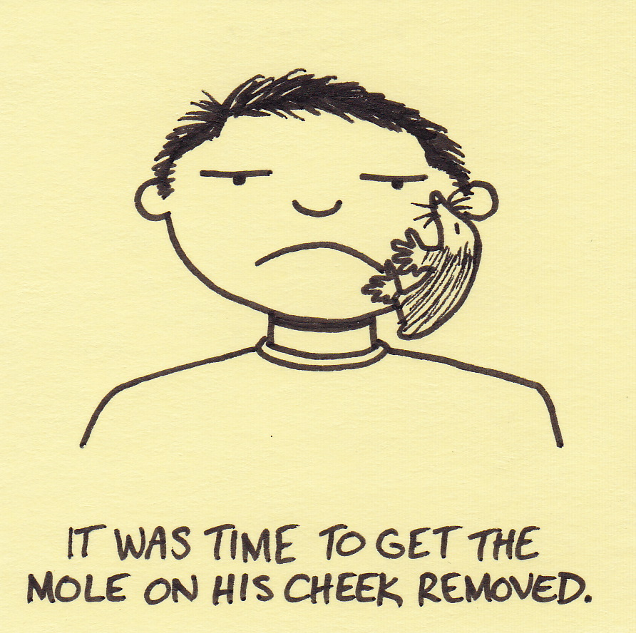

Add Feedback

Username:

Password:

Male

Female

Birthday:

Username:

Password:

Save

Phone:

Log In

Sign up

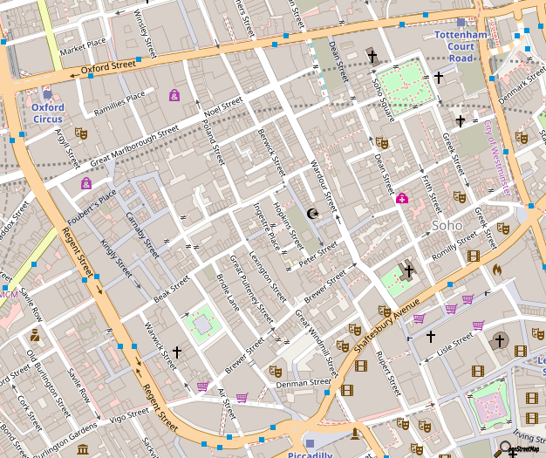

[This Photo](http://en.wikipedia.org/wiki/File:Soho_-_map_1.png) by Unknown Author is licensed under [CC BY-SA](https://creativecommons.org/licenses/by-sa/3.0/)

Photos

List

Mole

Bruise

5

10

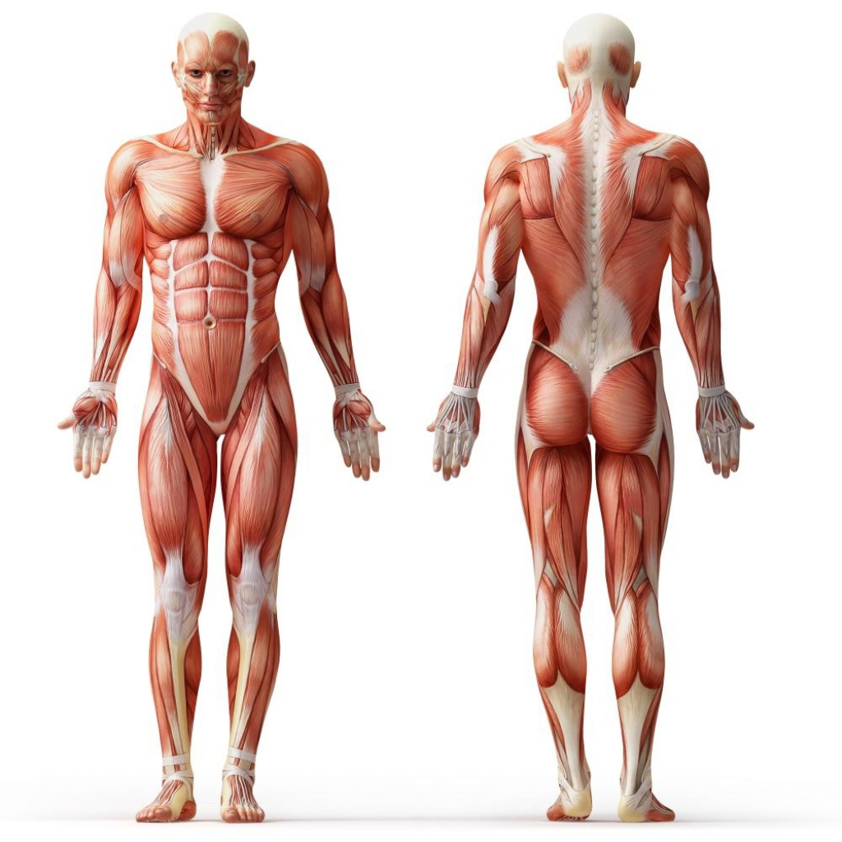

Title

Comments:

Add photos



Touch a body part



Edit

Add



Touch a body part

Mole

Bruise

5

10

Touch a body part



Delete

Comments:

Add Geo Location

Add reminder

Save



Set Reminder:

Weekly

Bi-weekly

Monthly

Start Date:

End Date:

Set Time:

CMPUT 301 Project

Initial Startup STORYBOARD STATE

CMPUT 301 Project

HOME – Care provider

CMPUT 301 Project

HOME – Patient

CMPUT 301 Project

SETTINGS – Care provider

CMPUT 301 Project

SETTINGS – Patient

CMPUT 301 Project

List/Maps/Gallery – Care Provider

CMPUT 301 Project

Main Applciation Photos - Patient